Welcome to the Kindergarten World of Color!!!
 |  | 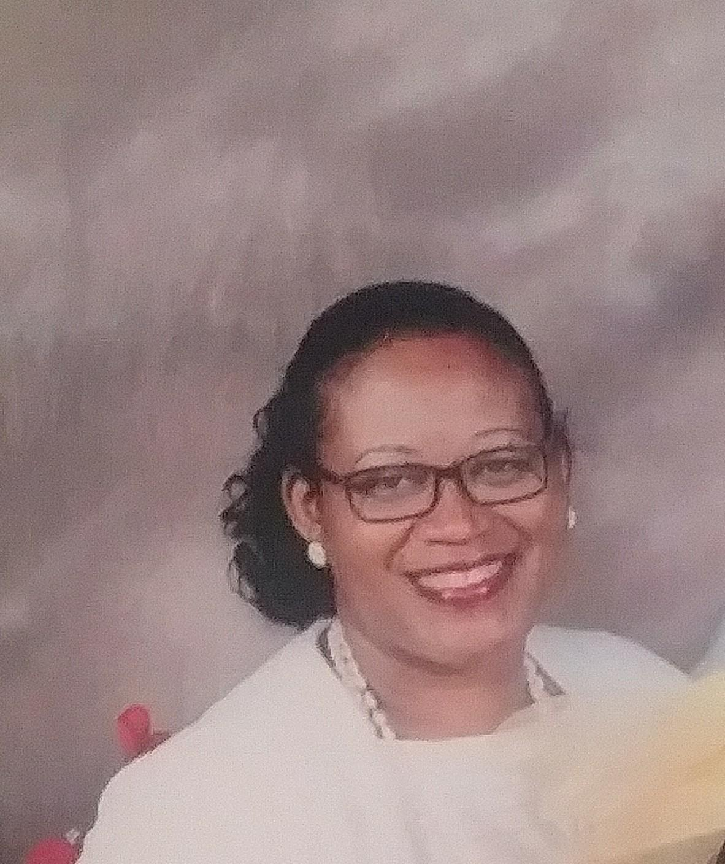
Ms. Baldwin  I am a Georgia native, product of Fulton County Schools. I went on to receive my BS. From The Fort Valley State University where I pledged Delta Sigma Theta Sorority Inc. I went on to receive my Masters degree from Mercer University.  Educating our youth has always been a  passion of mine. I truly belive we are  all born with a special talent and purpose.  As an educator I feel my job is to stir up  the talents in which my students already  posess. All children can learn when  given the proper tools and strategies to  be sucessful.  Recently, I have become an author of a book titled Memories of a Daughter’s Cry. It is a true story on my life as it pertains to the heartache of loosing my father to prostate cancer. Since, I have become an advocate for the disease by often speaking at functions to spread awareness.  In my spare time I also love traveling, eating, attending comedy shows and laughing until my stomach aches.  Contact Information: baldwinb@fultonschools.org | “I  puz | Mrs. Hellams  As an educator, my objective isn’t personal gain or material gain. It is not to find an easy profession that will not require much effort. My objective is to help each and every child realize their full God-given potential. My job is to pass the torch from one generation to the next in order to help children on their path to success. All children are born with a great talent inside them, and as a teacher, my goal is to help cultivate that talent to ensure that they grow to become great beacons of light in our society.  As the late Whitney Houston said, the children are our future. I believe that with teaching and mentoring of these amazing young spirits, the future will be very bright.  I am a Georgia native, a wife, and a mother of five children. I attended college at Fort Valley State University! I have been working in Fulton County Schools for 12 years. My hobbies are traveling, reading, and doing crosswords puzzles.  Contact Information: hellamsa@fultonschools.org
We are glad and fortunate that we have an opportunity to work with you and your scholars for the 2018-2019 school year! This year will be full of hands on and engaging learning. We look forward to having a great year! Thank you!

